Identify usability issues in following application interfaces by reviewing below storyboards.

Storyboard 1: An elderly person using a banking app

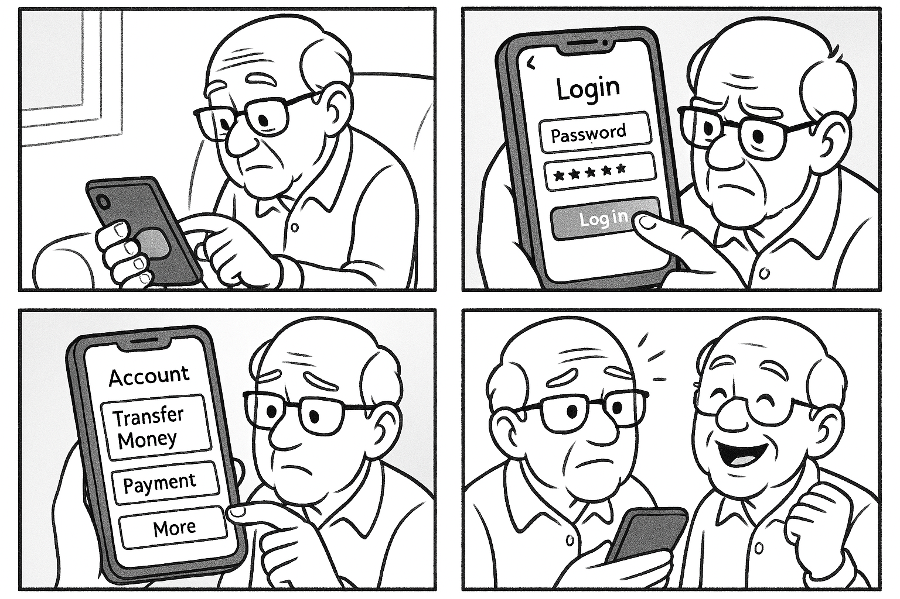
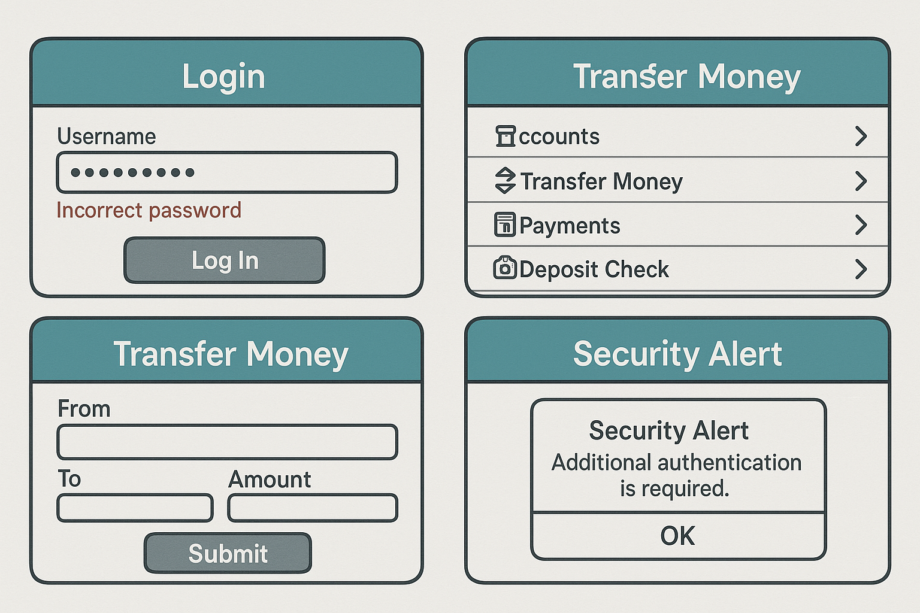

Usability issues highlighted in above storyboard include:
- Login Screen – Tiny text fields, unclear error messages.
- Main Menu – Overcrowded layout, unclear icons.
- Transfer Money Screen – Confusing button placement, difficult-to-read text.
- Security Alert – A poorly worded pop-up causing confusion.

Storyboard 2: A student using an educational website
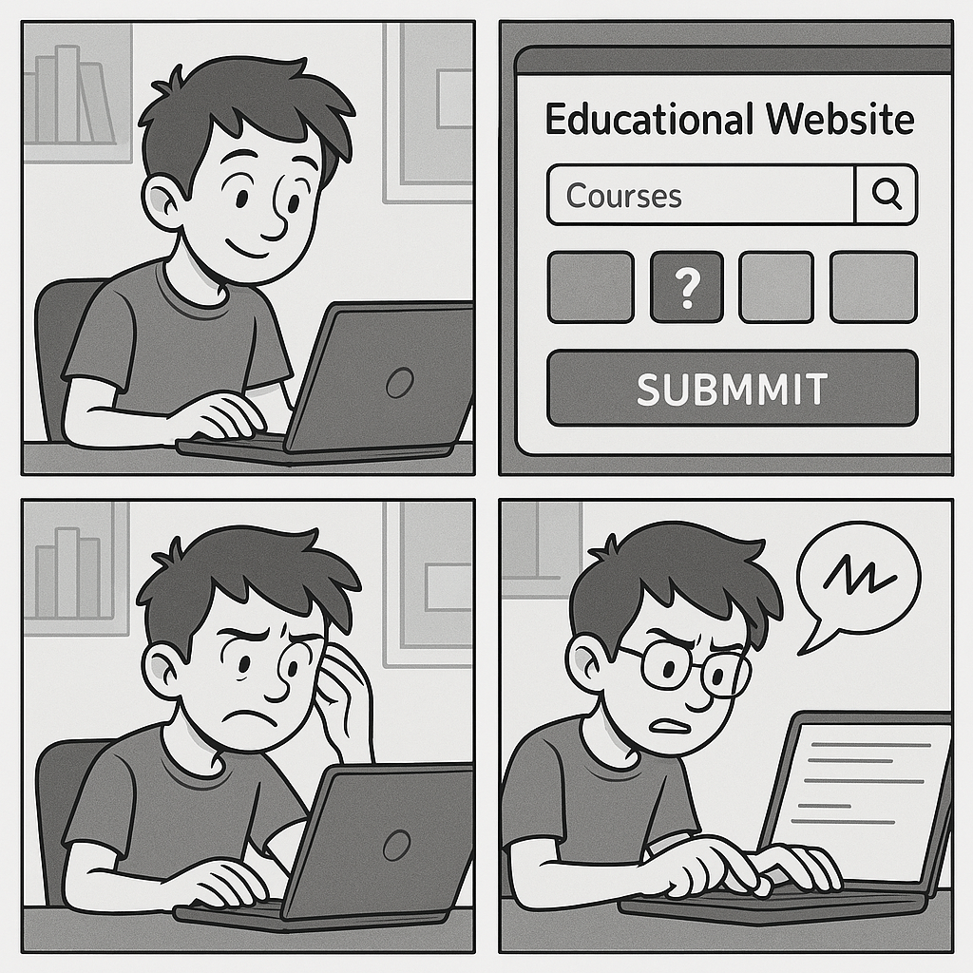
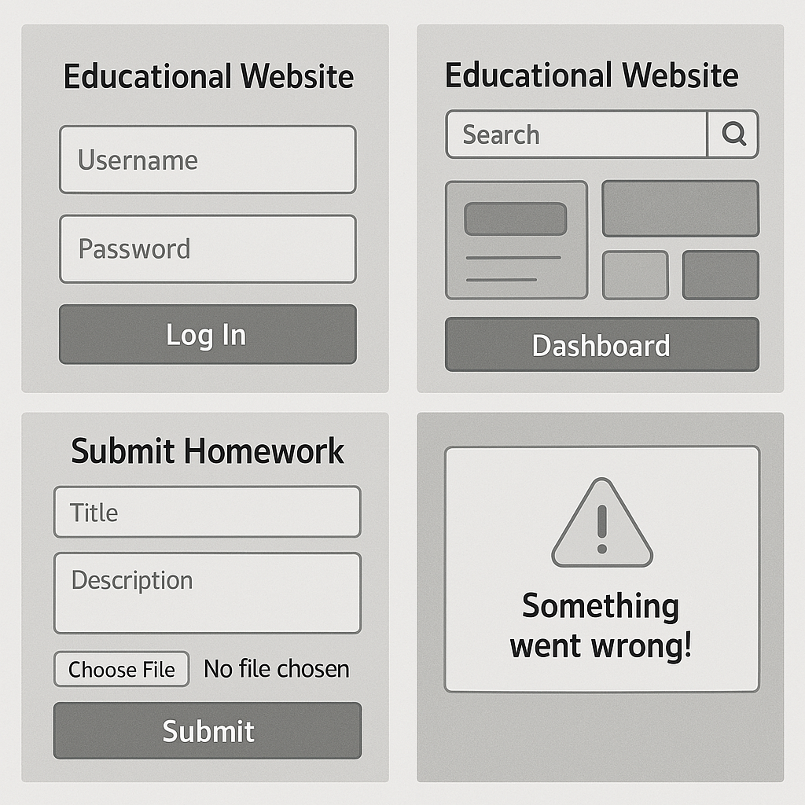

Can you work out the issues?

